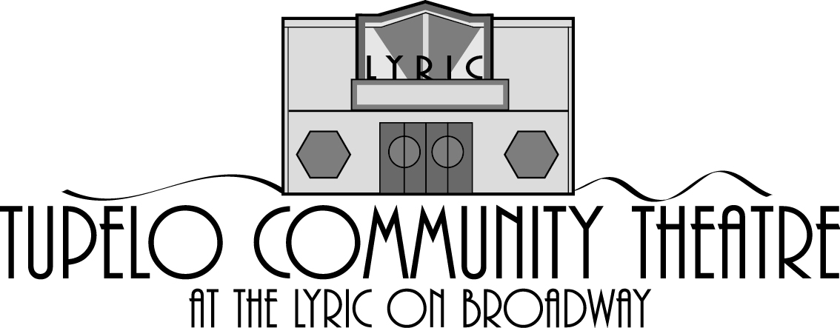
TCT PLAY Time REGISTRATION PRICES: $20 per child $10 per sibling
**Payment should be made at time of registration. **
Child #1 ( ) Boy ( ) Girl
Child’s Last Name____________________________ First Name__________________________________
Child’s Date of Birth________________
Child #2 ( ) Boy ( ) Girl
Child’s Last Name____________________________ First Name__________________________________
Child’s Date of Birth________________
Child #3 ( ) Boy ( ) Girl
Child’s Last Name____________________________ First Name__________________________________
Child’s Date of Birth________________
Parent/Guardian Name(s):_________________________________
Mailing Address__________________________________ City, State Zip____________________________
Telephone Number(s)_____________________________________________________________________
Email address___________________________________________________________________________
MEDICAL CONCERNS/ALLERGIES (including food allergies) that we need to be aware of while your child is with us: Name: ______________________________ Allergy: ________________________________________________
Name: ______________________________ Allergy: _______________________________________________
Name: _______________________________ Allergy: _______________________________________________
EMERGENCY CONTACT (other than yourself)
Name_____________________________________Phone_____________________
Name_____________________________________Phone_____________________
PERSONS AUTHORIZED TO PICK UP CHILD(ren) (including yourself): Names:________________________________________________________________________________
PHOTO RELEASE: Is it okay if we take your child’s picture and use it on our Website/Instagram/Facebook Fan Page?
YES: ____ NO:____ Parent/Guardian Signature (if present) _______________________________________________
Please email form to 1tct@bellsouth.net or bring to Lyric office 201 N. Broadway
Call (662) 844-1935 to make payment arrangements or for more information.

